Pokhara University

Level: Bachelor | Semester – Spring | Year : 2008
Programme: BE |  | Full Marks: 100
Course: Engineering Mathematics II |  | Time : 3hrs.

Candidates are required to give their answers in their own words as far as practicable.
The figures in the margin indicate full marks.

Attempt all the questions.

 | - Find the shortest distance between the lines  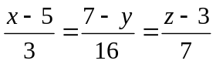and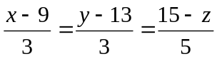. Find also the equation of shortest distance.  - A sphere S has points (0,1,0), (3,-5,2) at opposite ends of a diameter. Find the equation of the sphere having the intersection of the sphere S with the plane 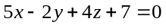as a great circle. | 8  7
 | - Find the minimum value of f(x, y, z) = x² + y² + z² such that x + y + z = 3a².  - Define homogeneous function of two variables. Verify Euler's theorem for u = x^{n} sin (y/x).  OR  Verify Euler’s theorem for a function 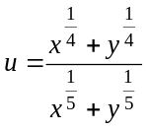. | 7  8  8
 | - Evaluate the double integral 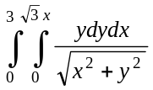, by changing Cartesian integral to equivalent polar integral.  - Find the volume of the solid that lies in the first octant and is bounded by the three co-ordinate planes and the cylinder x² + y² = 9 and y² + z² = 9. | 8  7
 | - Solve + y cotx = 2cosx.  - Find the general solution of the differential equation: 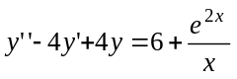. | 7  8
 | - Solve y" – 4y = 0 by power series method.  OR  Define Bessel function of the first kind. Also show that J₀' (x) = -J₁ (x).  - Solve the initial value problem: 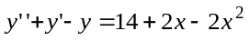, 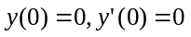. | 7  7  8
 | - Evaluate the following:  i) L(tcoswt) ii) L⁻¹ 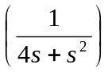  - Solve by Laplace transformation: 4y" + 8y' + 5y = 0, y (0) = 0, y' (0) = 1. | 8  7
 | Short questions:  - Write the general equation of a cone with its vertex at the origin.  - Find if x³ + y³ = 3axy. Using partial derivative method.  - Find the equation of the sphere whose centre is (1, 3, 2) and radius 3.  - Find laplace transform of te^{t}.  - Sketch the region of integration bounded by the equations  y² = -x, x – y = 4, y = -1, y = -2. | 5×2

